CORS Middleware

📝Definition
# Source: AI Source: Provided by: [Data Path: Persons Table -> ID Column: 1, Name_En Column: Motasem Essam] -> From: [ChatGPT] on [1/23/2026]
CORS (Cross-Origin Resource Sharing) Middleware controls which external domains are allowed to access your server resources.
👉 It answers the question: “Can this web page from another domain use my API?”

🔑 Key Responsibilities
# Source: AI Source: Provided by: [Data Path: Persons Table -> ID Column: 1, Name_En Column: Motasem Essam] -> From: [ChatGPT] on [1/23/2026]
- Enable or restrict cross-origin HTTP requests
- Set HTTP headers such as:
  - Access-Control-Allow-Origin
  - Access-Control-Allow-Methods
  - Access-Control-Allow-Headers
- Protect the server from unauthorized cross-origin requests
- Support frontend-backend communication in separate domains

🔄 How It Works in Flow
# Source: AI Source: Provided by: [Data Path: Persons Table -> ID Column: 1, Name_En Column: Motasem Essam] -> From: [ChatGPT] on [1/23/2026]
Browser → Request → CORS Middleware → Controller → Response
- Browser sends a cross-origin request
- CORS Middleware checks allowed origins
- Returns allowed headers and methods
- Request continues only if allowed ✅

🧱 Examples

1️⃣ Laravel CORS Middleware
# Source: AI Source: Provided by: [Data Path: Persons Table -> ID Column: 1, Name_En Column: Motasem Essam] -> From: [ChatGPT] on [1/23/2026]
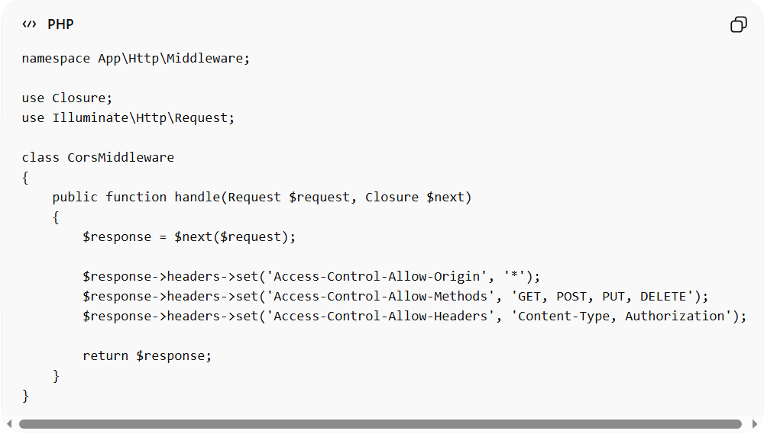
namespace App\Http\Middleware;

use Closure;
use Illuminate\Http\Request;

class CorsMiddleware
{
public function handle(Request $request, Closure $next)
{
$response = $next($request);

$response->headers->set('Access-Control-Allow-Origin', '*');
$response->headers->set('Access-Control-Allow-Methods', 'GET, POST, PUT, DELETE');
$response->headers->set('Access-Control-Allow-Headers', 'Content-Type, Authorization');

return $response;
}
}
Usage:
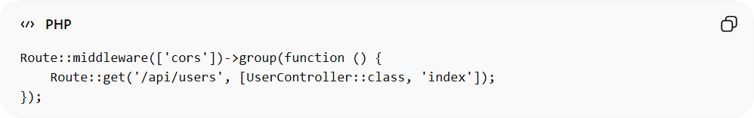
Route::middleware(['cors'])->group(function () {
Route::get('/api/users', [UserController::class, 'index']);
});

2️⃣ Preflight Request Example
# Source: AI Source: Provided by: [Data Path: Persons Table -> ID Column: 1, Name_En Column: Motasem Essam] -> From: [ChatGPT] on [1/23/2026]
- Browser sends an OPTIONS request first
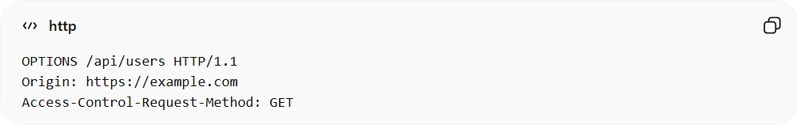
OPTIONS /api/users HTTP/1.1
Origin: https://example.com
Access-Control-Request-Method: GET
- Server responds with allowed headers/methods
- Actual request proceeds if allowed

❌ Bad Example (No CORS Middleware)
# Source: AI Source: Provided by: [Data Path: Persons Table -> ID Column: 1, Name_En Column: Motasem Essam] -> From: [ChatGPT] on [1/23/2026]
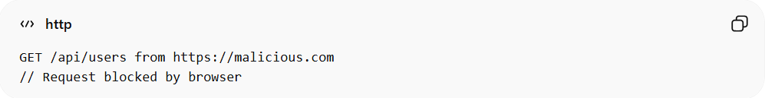
GET /api/users from https://malicious.com
// Request blocked by browser
Problems:
- Browser blocks legitimate frontend requests ❌
- Hard to manage allowed origins ❌

✅ Good Example (Using CORS Middleware)
# Source: AI Source: Provided by: [Data Path: Persons Table -> ID Column: 1, Name_En Column: Motasem Essam] -> From: [ChatGPT] on [1/23/2026]
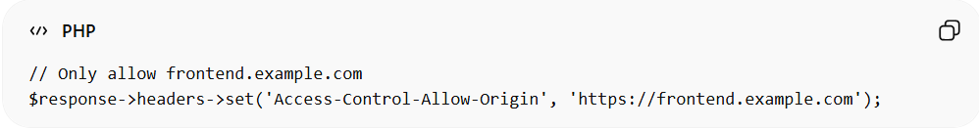
// Only allow frontend.example.com
$response->headers->set('Access-Control-Allow-Origin', 'https://frontend.example.com');
- Allows legitimate domains ✅
- Protects server resources ✅
- Centralized and reusable ✅

🔄 Relation to Other Middleware
# Source: AI Source: Provided by: [Data Path: Persons Table -> ID Column: 1, Name_En Column: Motasem Essam] -> From: [ChatGPT] on [1/23/2026]
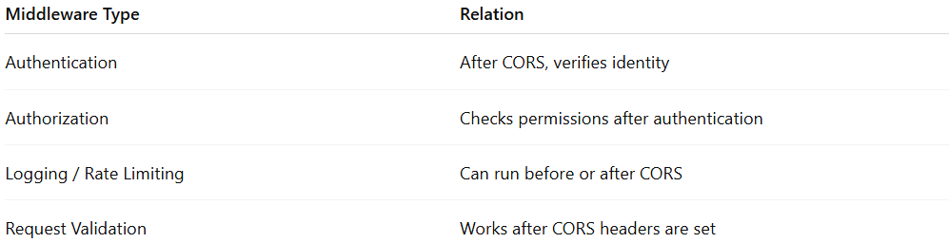
Middleware Type | Relation
Authentication | After CORS, verifies identity
Authorization | Checks permissions after authentication
Logging / Rate Limiting | Can run before or after CORS
Request Validation | Works after CORS headers are set

⚠️ Common Mistakes
# Source: AI Source: Provided by: [Data Path: Persons Table -> ID Column: 1, Name_En Column: Motasem Essam] -> From: [ChatGPT] on [1/23/2026]
- Allowing * in production for sensitive APIs ❌
- Forgetting to handle preflight OPTIONS requests ❌
- Adding CORS headers in Controller instead of middleware ❌

💡 Key Idea
# Source: AI Source: Provided by: [Data Path: Persons Table -> ID Column: 1, Name_En Column: Motasem Essam] -> From: [ChatGPT] on [1/23/2026]
CORS Middleware is essential for safe cross-origin communication, especially for frontend apps hosted on different domains.

🧾 Summary
# Source: AI Source: Provided by: [Data Path: Persons Table -> ID Column: 1, Name_En Column: Motasem Essam] -> From: [ChatGPT] on [1/23/2026]
- Controls cross-origin requests
- Adds necessary HTTP headers
- Must handle preflight OPTIONS requests
- Keeps APIs secure and accessible

